**[Image visualization using transparency](http://blogs.mathworks.com/steve/2008/08/20/image-visualization-using-transparency/" \o "Permanent Link to Image visualization using transparency)**

Transparent graphics objects can be used effectively to visualize image processing concepts. Two particularly useful techniques are:

* Highlighting image regions with transparent patches
* Displaying one image transparently over another

Today I'll show how to highlight image regions with patches. For this example I'll use the 'Extrema'measurement returned by [regionprops](http://www.mathworks.com/access/helpdesk/help/toolbox/images/regionprops.html). The extrema for a given object are eight points: the left-most pixel on the bottom, the right-most pixel on the bottom, the top-most pixel on the right, the bottom-most pixel on the right, and so on.

I'll start with the rice image, segmenting it using techniques I've shown before.

I = imread('rice.png');

imshow(I)

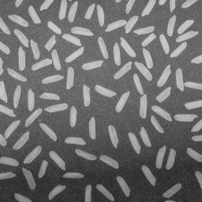

Even out the illumination with the tophat operator, threshold, and then clean up the thresholded image a bit.

I2 = imtophat(I, ones(15, 15));

bw = im2bw(I2, graythresh(I2));

bw2 = bwareaopen(bw, 5);

bw3 = imclearborder(bw2);

imshow(bw3)

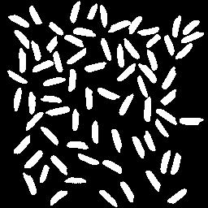

Label the binary objects and compute the extrema.

L = bwlabel(bw3);

s = regionprops(L, 'Extrema');

Each object has 8 extrema points associated with it.

s(1).Extrema

*ans =*

*11.5000 86.5000*

*12.5000 86.5000*

*34.5000 100.5000*

*34.5000 102.5000*

*33.5000 103.5000*

*27.5000 103.5000*

*9.5000 89.5000*

*9.5000 87.5000*

We can superimpose the extrema-bounded shapes on top of the original rice image by using patch objects.

imshow(I)

hold on

for k = 1:numel(s)

x = s(k).Extrema(:,1);

y = s(k).Extrema(:,2);

patch(x, y, 'g')

end

hold off

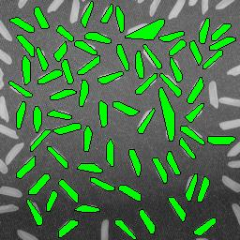

The above visualization is pretty clear. If you zoom in on some of the odd, larger shapes, though, you can't really tell what's going on.

axis([120 200 1 75])

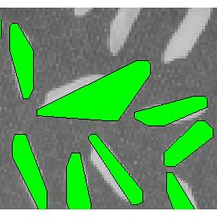

We solve that by displaying the patches transparently.

imshow(I)

hold on

for k = 1:numel(s)

x = s(k).Extrema(:,1);

y = s(k).Extrema(:,2);

patch(x, y, 'g', 'FaceAlpha', 0.3)

end

hold off

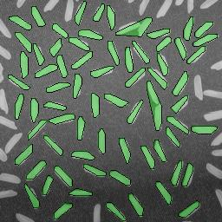

Now if you zoom in on the same region, we can see exactly what caused the unusual region.

axis([120 200 1 75])

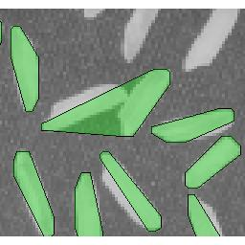

Two of the rice grains were touching.

Next time I'll show a couple of techniques for visualizing one image transparently superimposed on another.